1. If this is your first time running SAS before logging in, ensure that you have a SAS folder located on T drive

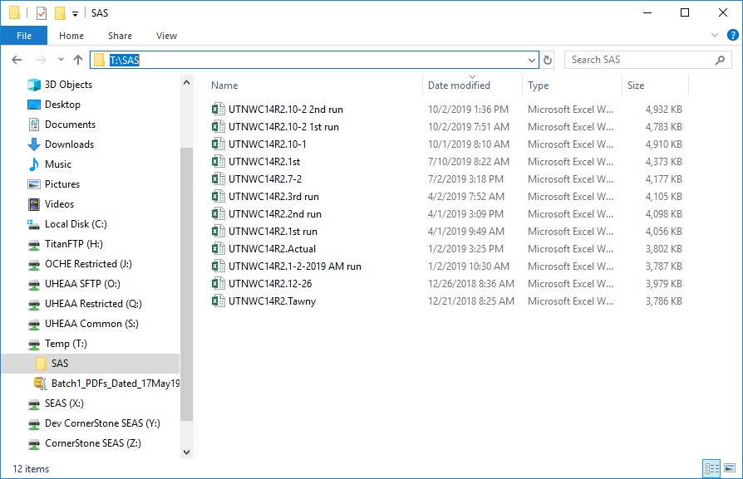

* 1. This will need to be manually created before running
     1. If the folder missing, some SAS jobs will not be able to write the output and will give an error

1. Logging in Manually
   1. The user will first need to open a SAS tunnel to communicate with the AES warehouse. In order to do so Launch the “Launch AESLink.NET.exe”

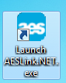

* 1. Select “Open SSH Tunnel for SAS”

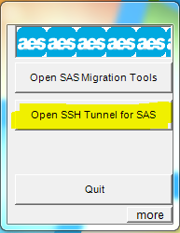

* 1. Insert SAS User ID
     1. User ID will begin with “RM”
     2. If you have not received a User ID, contact systems support
  2. Insert the server
     1. Fed Live/Test (Legend)
        1. Host203.aessuccess.org
     2. Uheaa Live (Duster)
        1. Host143.aessuccess.org
     3. Uheaa Test
        1. Host34.aessuccess.org
  3. Insert your password
     1. The password does not display as you type.
     2. If successfully logged in, will be display a “$”

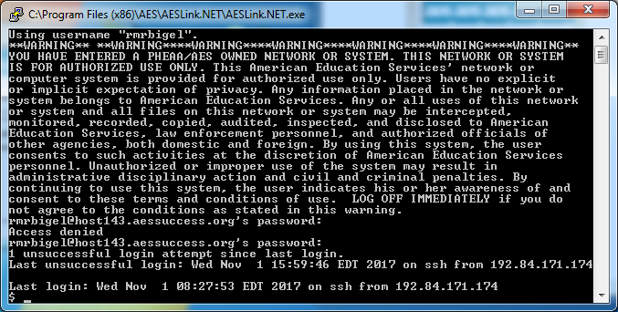

* 1. Once the tunnel has been successfully access, the user will now need to connect SAS to the tunnel. In order to do this, the user will need to access GIT (https://github.uheaa.ushe.local/UHEAA/Queries/tree/master/Samples) and launch one of the following jobs depending on which server the user is trying to connect to
     1. Connect to Duster prod (uheaa live)
     2. Connect to (Uheaa Test)
     3. Connect to Legend Prod (Cornerstone Live/Test
        1. Click job name
        2. Select Raw
        3. Then Copy code
  2. Launch the SAS application and paste code into the editor window.
     1. Press F3
  3. Insert SAS User ID in the “Userid?” popup window

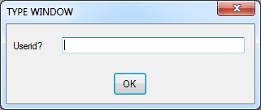

* 1. Insert sas password in the “Password?” pop up window

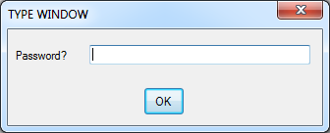

* 1. If the following message is received then User has successfully Connected SAS to the AES tunnel. The user can now run SAS jobs

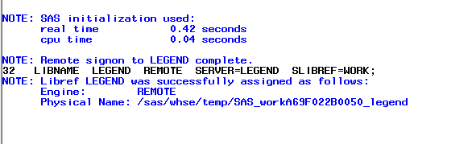

TIP: If the SAS remains unused or running a job that takes more than 30 minutes to run it will eventually time out and will need to be reconnected. You can use the S:\12-22-16\Plinker to keep your tunnel active and prevent it from timing out

1. Logging in with SAS Manager (currently only works with Duster – Uheaa live and Legend- Cornerstone live/test) SAS Manger is an application that prevents tunnel time out while running sas jobs.
   1. On the network access X:\PADU\Applications
      1. Drag and drop the SASM Folder on to your desktop
   2. Launch the SASM application



* 1. Once inside the application click on the options button (Gear)

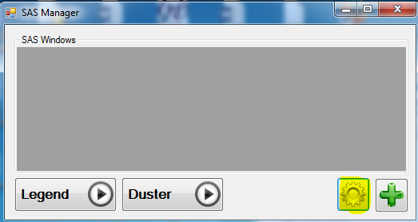

* 1. Insert your User Name and a password(s) for Duster and Legend
     1. The password will need to be set up manually before using the application

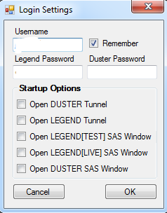

* 1. Once user has added user name and passwords click on the Green plus symbol to connect to an AES Tunnel and SAS

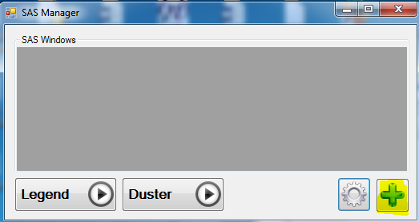

* 1. If the following message is received then User has successfully Connected SAS to the AES tunnel. The user can now run SAS jobs

